1. FIRST Set Algorithm
The FIRST set of a symbol is the set of terminals that can begin a string derived from that symbol.
- Terminal Rule: If the symbol is a terminal, its FIRST set contains only itself.
- Non-Terminal Rule: If the symbol is a non-terminal $A$, we examine all productions $A→Y_{1}Y_{2}…Y_{n}$.
- Epsilon Handling: If $A→\#$(epsilon) is a production, add $\#$ to $FIRST(A)$.
- Derivation Chain: For a production $A→Y_{1}Y_{2}…Y_{n}$, we compute $FIRST(Y_{1})$. If $FIRST(Y_{1})$ contains $\#$, we continue to $Y_{2}$, and so on.

2. FOLLOW Set Algorithm
The FOLLOW set of a non-terminal $A$ is the set of terminals that can appear immediately to the right of $A$ in any sentential form.
- Start Symbol Rule: The start symbol always includes the end-marker $\$$ in its FOLLOW set.
- Scanning RHS: To find $FOLLOW(B)$, we search the right-hand side of all productions for the occurrence of $B$.
- Immediate Neighbor Rule: In a production $A→αBβ$, everything in $FIRST(β)$ (except $\#$) is added to $FOLLOW(B)$.
- Recursive Rule: In a production $A→αB$ or $A→αBβ$ where $FIRST(β)$ contains $\#$, everything in $FOLLOW(A)$ is added to $FOLLOW(B)$.

3. LL(1) Table Construction Algorithm
The table $M[A, a]$ tells the parser which production to use for a non-terminal $A$ and lookahead terminal $a$.
- Rule 1 (Using FIRST): For every terminal $a$ in $FIRST(RHS)$, add the production $A→RHS$ to $M[A, a]$.
- Rule 2 (Using FOLLOW): If $\#$ is in $FIRST(RHS)$, then for every terminal $b$ in $FOLLOW(A)$, add $A→RHS$ to $M[A, b]$.
- Rule 3 (EOF): If $\#$ is in $FIRST(RHS)$ and $\$$ is in $FOLLOW(A)$, add $A→RHS$ to $M[A, \$]$.

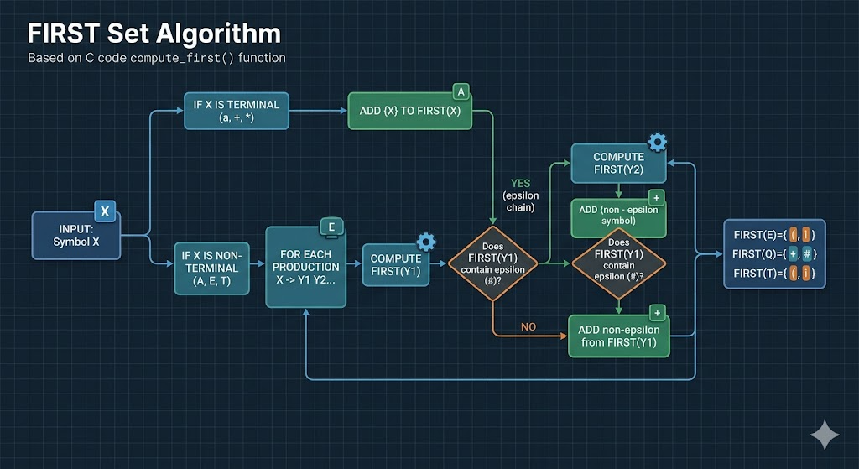
1
This visual shows the full flow of compute_first, including the decision points for recursion and handling epsilon (#) derivations in production rules.
Key Takeaways:
- Terminals (a, +, …): Add only the terminal itself to its FIRST set.
- Epsilon (#): If a non-terminal derives #, this is added to its FIRST set.
- Nullable Chain: If $FIRST(Y_{1})$ contains #, the algorithm must look at $FIRST(Y_{2})$, and potentially further down the string, collecting terminals along the way.

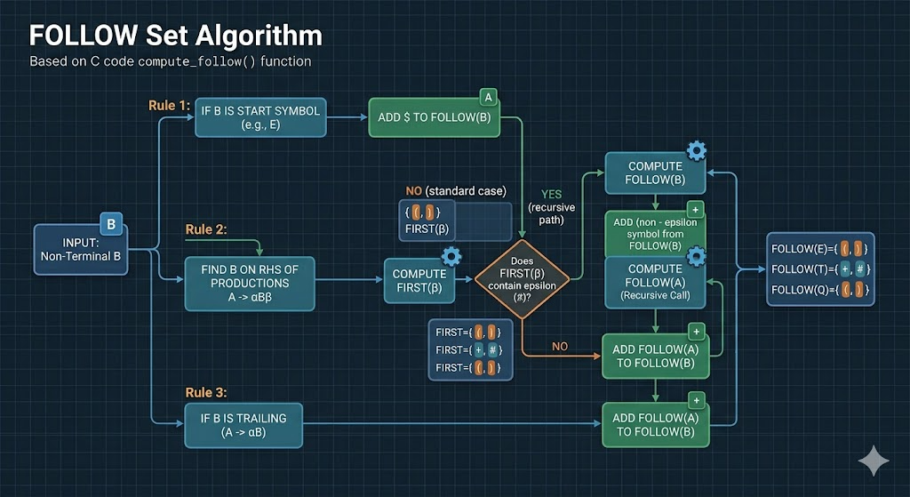
2
This visual detail the compute_follow flow, explicitly showing the interaction with FIRST sets and recursive calls, which is a major point of collaboration between your two modules.
Key Takeaways:
- Start Symbol Rule: The start symbol ($S$, or $E$ in this example) always gets $\$$ in its FOLLOW set.
- Right Neighbors (Rule 2): For a production $A→αBβ$, add $FIRST(β)$ (excluding $\#$) to $FOLLOW(B)$. This step visually refers to the FIRST sets calculated previously (Image 1).
- Trailing Non-Terminals (Rule 3): If $A→αB$ or if $FIRST(β)$ contains $\#$, add $FOLLOW(A)$ to $FOLLOW(B)$, often requiring recursive calls.

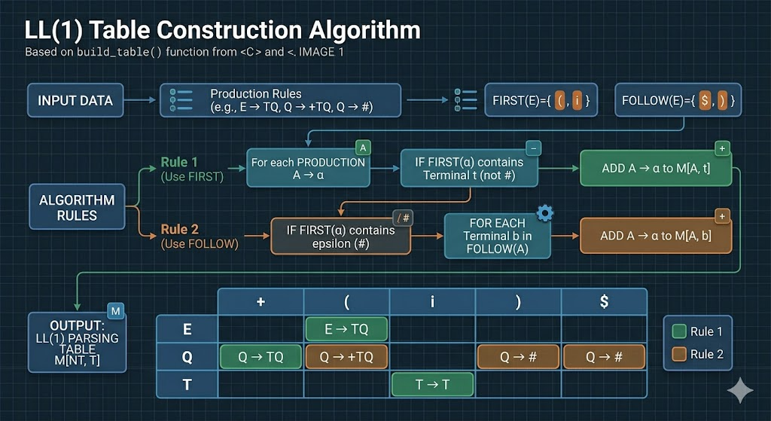
3
This visual shows the multi-stage process of taking the FIRST sets (Image 1), the FOLLOW sets (Image 2), and applying the rules to populate the final parsing table structure, perfectly organized.
Key Takeaways:
- Rule 1 (Use FIRST): For each terminal $a$ in $FIRST(RHS)$, add the production $A→RHS$ to entry $M[A, a]$. This step relies heavily on FIRST sets (Image 1).
- Rule 2 (Use FOLLOW): If $\#$ (epsilon) is in $FIRST(RHS)$, then for each terminal $b$ in $FOLLOW(A)$, add $A→RHS$ to $M[A, b]$. This step relies on FOLLOW sets (Image 2).
- EOF Rule: If $\#$ is in $FIRST(RHS)$ and $\$$ is in $FOLLOW(A)$, add $A→RHS$ to $M[A, \$]$.
- Table Structure: The resulting table, perfectly organized with different color highlights for Rule 1 and Rule 2, visually maps each production to its unique parsing cell.

